Experiment No: 3
Apply Decision Tree and Random Forest for classification tasks

1. Dataset Source
The dataset used for this experiment is the Titanic survival dataset.
Source Link:
https://www.kaggle.com/datasets/yasserh/titanic-dataset

2. Dataset Description
The Titanic dataset contains information about passengers aboard the Titanic and whether they survived or not.
- Number of Instances: ~891 passengers
- Number of Features: 12 columns

🔹 Features:
- PassengerId
- Pclass (Ticket class)
- Name
- Sex
- Age
- SibSp (siblings/spouses aboard)
- Parch (parents/children aboard)
- Fare
- Embarked (port of boarding)

🔹 Target Variable:
- Survived
  - 0 = Not Survived
  - 1 = Survived
The dataset is suitable for classification tasks and is widely used for machine learning experiments.

3. Mathematical Formulation of the Algorithms

🔹 Decision Tree
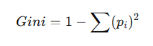
Decision Tree works by splitting data based on feature values using criteria like Gini Index:

Where:
- pi​ = probability of class i
The algorithm selects features that minimize impurity at each split.
🔹 Random Forest
Random Forest is an ensemble of multiple decision trees.
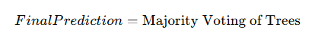
It uses:
- Bootstrap sampling
- Random feature selection
This reduces overfitting and improves accuracy.

4. Algorithm Limitations

🔹 Decision Tree Limitations
- Prone to overfitting
- Sensitive to small data changes
- Can create complex trees

🔹 Random Forest Limitations
- Computationally expensive
- Less interpretable
- Requires more memory

5. Methodology / Workflow
- Dataset Collection
Load the Titanic dataset
- Data Preprocessing
  - Handle missing values (Age, Embarked)
  - Encode categorical variables (Sex, Embarked)
  - Drop irrelevant columns (Name, PassengerId)
- Feature Selection
  - Define input features (X)
  - Define target variable (y = Survived)
- Train-Test Split
  - Split dataset into training and testing sets
- Model Training
  - Train Decision Tree classifier
  - Train Random Forest classifier
- Model Evaluation
  - Accuracy
  - Confusion Matrix
  - Classification Report
- Hyperparameter Tuning
  - Tune parameters using GridSearchCV
- Result Analysis
  - Compare both models

6. Performance Analysis

🔹 Decision Tree Performance:
- Provides good accuracy
- May overfit training data

🔹 Random Forest Performance:
- Higher accuracy than Decision Tree
- Better generalization
- More stable predictions
Evaluation Metrics:
- Accuracy
- Precision
- Recall
- F1-score
Random Forest typically performs better due to ensemble learning.

7. Hyperparameter Tuning
Hyperparameter tuning is done using GridSearchCV.

🔹 Decision Tree Parameters:
- max_depth
- min_samples_split

🔹 Random Forest Parameters:
- n_estimators
- max_depth
- min_samples_split
Tuning improves performance by selecting optimal parameters and reducing overfitting.
Code:
# ================= STEP 1: IMPORT LIBRARIES =================
import numpy as np
import pandas as pd
import matplotlib.pyplot as plt
import seaborn as sns

from sklearn.model_selection import train_test_split, GridSearchCV
from sklearn.tree import DecisionTreeClassifier
from sklearn.ensemble import RandomForestClassifier
from sklearn.metrics import accuracy_score, confusion_matrix, classification_report

# ================= STEP 2: LOAD DATASET =================
df = pd.read_csv("Titanic-Dataset.csv")

print("Dataset Preview:\n", df.head())
print("\nDataset Shape:", df.shape)

# ================= STEP 3: DATA PREPROCESSING =================
# FIXED WARNING ISSUE (no inplace)

df['Age'] = df['Age'].fillna(df['Age'].mean())
df['Embarked'] = df['Embarked'].fillna(df['Embarked'].mode()[0])

# Convert categorical to numeric
df = pd.get_dummies(df, columns=['Sex', 'Embarked'], drop_first=True)

# Drop unnecessary columns
df = df.drop(columns=['Name', 'PassengerId', 'Ticket', 'Cabin'])

# ================= STEP 4: FEATURES & TARGET =================
X = df.drop(columns=['Survived'])
y = df['Survived']

# ================= STEP 5: TRAIN TEST SPLIT =================
X_train, X_test, y_train, y_test = train_test_split(
X, y, test_size=0.2, random_state=42
)

# ================= DECISION TREE =================
dt = DecisionTreeClassifier(random_state=42)
dt.fit(X_train, y_train)

y_pred_dt = dt.predict(X_test)

print("\n=== Decision Tree ===")
print("Accuracy:", accuracy_score(y_test, y_pred_dt))
print("Confusion Matrix:\n", confusion_matrix(y_test, y_pred_dt))
print("Classification Report:\n", classification_report(y_test, y_pred_dt))

# 📊 Decision Tree Confusion Matrix Image
plt.figure(figsize=(5,4))
sns.heatmap(confusion_matrix(y_test, y_pred_dt),
annot=True, fmt="d", cmap="Blues")

plt.xlabel("Predicted")
plt.ylabel("Actual")
plt.title("Confusion Matrix - Decision Tree")
plt.show()

# ================= RANDOM FOREST =================
rf = RandomForestClassifier(random_state=42)
rf.fit(X_train, y_train)

y_pred_rf = rf.predict(X_test)

print("\n=== Random Forest ===")
print("Accuracy:", accuracy_score(y_test, y_pred_rf))
print("Confusion Matrix:\n", confusion_matrix(y_test, y_pred_rf))
print("Classification Report:\n", classification_report(y_test, y_pred_rf))

# 📊 Random Forest Confusion Matrix Image
plt.figure(figsize=(5,4))
sns.heatmap(confusion_matrix(y_test, y_pred_rf),
annot=True, fmt="d", cmap="Greens")

plt.xlabel("Predicted")
plt.ylabel("Actual")
plt.title("Confusion Matrix - Random Forest")
plt.show()

# ================= HYPERPARAMETER TUNING =================
param_grid = {
'n_estimators': [50, 100],
'max_depth': [3, 5, 10]
}

grid = GridSearchCV(RandomForestClassifier(random_state=42), param_grid, cv=5)
grid.fit(X_train, y_train)

print("\n=== HYPERPARAMETER TUNING ===")
print("Best Parameters:", grid.best_params_)
print("Best Accuracy:", grid.best_score_)

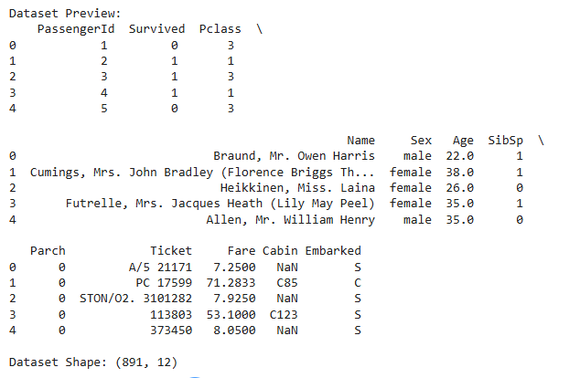
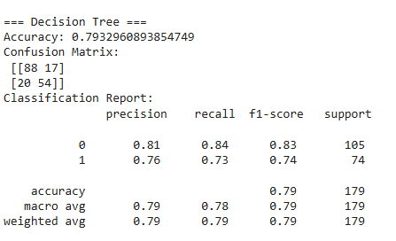
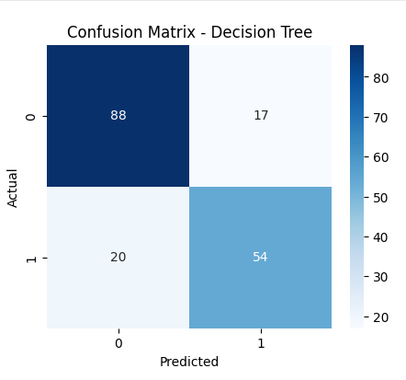

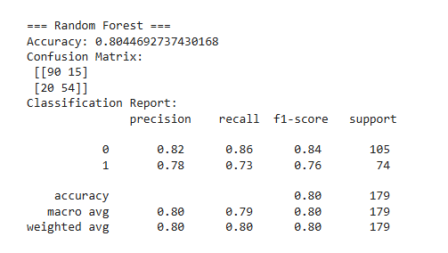
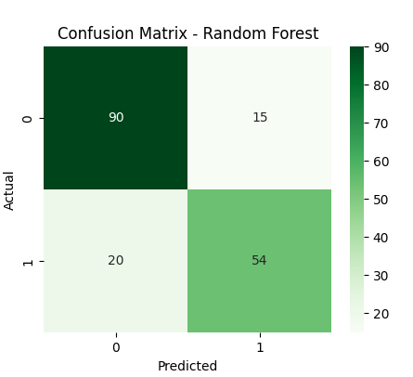
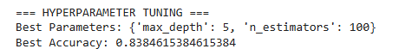
Conclusion:
Decision Tree and Random Forest were successfully implemented for classification. Random Forest gave better accuracy due to reduced overfitting.

